Casa Maj, Port Andratx, Mallorca
Carrer Llaut 3A (off Carrer Can Perot) Bloque 5, Apartment 1A.
Parking space number 28 (2nd one in from the right)
Code for pedestrian gate: [press key sign] then 1588
Hola and welcome to our beautiful home in Mallorca!
We appreciate your understanding that our apartment is not a holiday rental. It’s genuinely our home, and we have furnished it in the same way that we have our Chenies home: high-quality furniture, beds, and crockery.
We invite only a very few of our friends to stay here, and we trust you to use our home in the way that you would if we were there with you.
Renting in Mallorca is illegal, and our community of apartments is mainly Brits, some of whom live here fulltime, including our next door neighbours, Brian and Hazel Bradford. Hazel is Vice-Chairman of the Community Board. They will gladly help with anything you need.
Here are our requests of you:
DON’TS
- NO SMOKING, NEVER, ANYWHERE, INCLUDING THE TERRACE. (if you want to smoke just pop down to the gardens)

- Please don’t treat the sofa and chairs on the terrace as sun-loungers , and don’t sit on them with suncream on or it will mark the lovely white covers! There are plenty of sunloungers in the gardens for you to use

- When you’re sunbathing in the garden, please use the coloured towels in the hall cupboard

- Please make sure that you put the sunblinds back up when you leave the terrace

- Please DO NOT leave the aircon on when you go out. Electricity costs a fortune, and we have to pay the bill! It only takes 10 minutes after switching on for the room to cool, so please use with consideration

- MOST IMPORTANTLY… NEVER LEAVE THE APARTMENT WITH WINDOWS OPEN, AND DO NOT LEAVE WINDOWS OPEN WHEN IT LOOKS AS IF IT WILL RAIN. The apartment has flooded before, just through ONE bathroom window being left open – storms and wind can be sudden & extreme, so please take care.

- You’re welcome to use the gas bbq, but please don’t get it near the white furniture, and don’t put the grill in the dishwasher – there are brillo pads & bbq cleaner under the sink to clean it

- Finally, there are strict community rules that every apartment needs to comply with. A copy is in the apartment for you. Everyone takes these seriously, so please do respect them – for example, don’t hang laundry out on the balcony.

DO’S
- Feel free to help yourself to drinks, but please replace like-with-like. You’re welcome to use our coffee pods, but, again, please buy us a replacement tube of pods – there’s a gorgeous Nespresso shop in Palma that sells them

- We accommodate our guests in the guest bedroom suite, where everything is yours to use as you like. If you prefer to use our bathroom as well as / instead, you’re welcome

- Use the dishwasher on eco setting (29 mins is fine to clean dishes)

- Hang towels in the utility room on the airer and the breeze will dry them beautifully.

- If it’s windy or it looks like it might rain, please bring the terrace cushions inside

- Feel free to use the big candles but only outside on the terrace, as they’re outdoor candles

- Please do use the door wedges (the funny little rubber coloured things) – doors slam very easily in the breeze

- Please water our plants for us as often as you remember, there’s a blue bottle in the utility room, thanks!

- Just leave the hot water boiler plugged in while you’re there, and, as you leave at the end of your stay, please make sure you unplug the boiler in the utility room, thanks!

- PLEASE MAKE SURE YOU DOUBLE-LOCK THE FRONT DOOR WHENEVER YOU GO OUT!

- Finally, please just look after our home as if it were your own. If you use the bbq, then please clean it, and take the rubbish out to the big bin just outside the apartment (if you’re being very good, there’s a bottle bank at the end of Carrer Llaut (our little road) as you turn onto Carrer Can Perot)

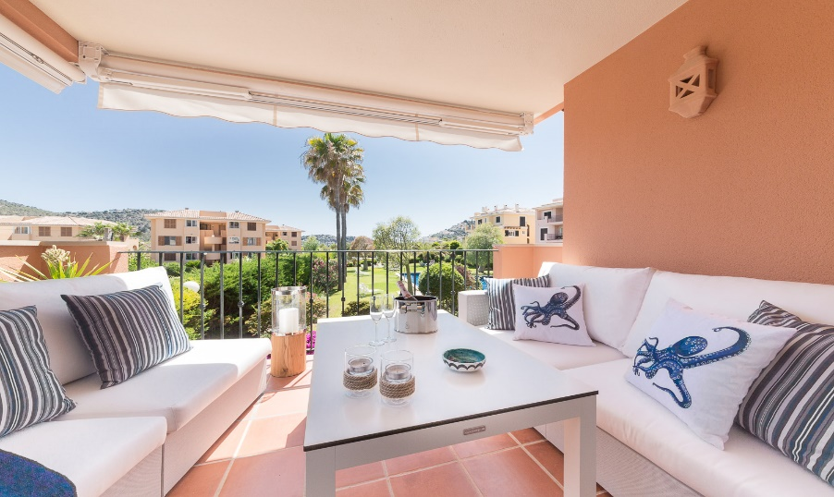

Places to go, things to see….

This is a rather hurried list of ideas, we will get better at this bit!
- You may want to take a look at our Mallorca books in the apartment, they are full of great places to go, whatever you fancy doing: Palma, Port Soller, Soller (take the old wooden train from Palma to Soller), Pollenca, Port de Pollenca, Formentor, Deia, Sa Dragonera (nature island, reachable by boat from Port Andratx)

- Beaches: Port Andratx has a tiny beach, tho it looks good fun to swim off the pontoon & rocks at the far end of town, people do it all the time

- If you want big, decent beaches, Camp de Mar is the closest (lots new flashy builds going on, though a fairly ghastly seventies hotel needs knocking down)

- Es Trenc, to the southeast of Palma, is renowned for its white sand and turquoise sea (we’ve never actually been!)

- Saint Elm beach is very sweet (next town to Port Andratx up the coast). Charming little town, with a wonderful restaurant on the front, Cala Cornills – the food’s brilliant, especially the paella. Stewart and I have whiled away several long lunches there, just looking out to sea (as opposed to looking at each other)

- If you just want spectacular sea views, you won’t get more dramatic than Cap Formentor (helluva drive along a cliffside road, don’t do it if you’re nervous), or – closer to home – Cala Llamp, next door to Port Andratx, just round the mountain – nothing much there as such, just truly stunning views of the sea

- Other places locally: Puerto Portals has a very flashy waterfront, good Irish restaurant Flanigan’s – but a bit too Puerto Banus-like for us

- Andratx (the town inland from Port Andratx) is really a locals’ place and distinctly unspectacular, although there is a market there every Wednesday

- Restaurants: there are (so says Sims, and he should know) 74 restaurants within 10 minutes of the apartment. When we get a bit more organised, we’ll do a proper guide. One of the best is actually at the end of our road, Vent de Tramuntana, with a gorgeous garden to it in, lovely food, great ambience

- You honestly can’t go wrong, they’re all good restaurants. If you just want a coffee, we like Cappuccino in the port – not the cheapest, but in our view it’s the nicest. And their iced coffee is to die for…

- Like any tourist place, the restaurants on the front are usually a bit more expensive and not always as good as some of the backstreet places, though Miramar does an excellent steak. Half the fun is really just gazing out over the water

- Check out Trip Advisor to make your own choices…..

- Near to home again, there’s La Gourmeda at the end of Carrer Can Perot. It’s German-run, but the food’s international, and all very pretty

- The sailing club (Club Vela), along the quayside at the end of our road, does a great cooked breakfast in the café. And the main restaurant is also very good, with lovely views out over the water

- If you want to push the boat out, metaphorically speaking, there’s always the Michelin-starred Urbano, in the port, or Villa Italia up the hillside at the far end of town. Neither’s cheap!

- Supermarkets: if you want to do a big shop as you arrive, there’s a superb Carrefour just after you get on the motorway from the airport, first junction off, clearly signposted, easy to park

- For day-to-day stuff, there’s a fantastic little supermarket at the far end of the port that sells just about everything – Aprop. The meat’s particularly good and it has a car park

- Eroski in the port is good for fish: no car park, but just use the main car park for the port by the bridge

- Fish: they do still bring in the fish at the port every day and sell it, but we’ve not got around the doing it yet.

- Pharmacy: as you walk into town, and over the bridge, just past the fish market cross the main road and the pharmacy is opposite. They’re open all kinds of hour, are really helpful and speak excellent English

- Doctor: If you’re unfortunate enough to need a doctor, there’s a superb medical centre in Andratx, you just turn up, show them your Europe Health card, and you get treated for free (for the moment at least…)

- English: it’s so international here, everyone speaks English

- Taxi: there is a taxi card in the drawer in the kitchen. In the port, the taxis queue up outside the Eroski supermarket, just in case you feel a little delicate and not quite up to the walk home

- Nightclub: if you should feel the urge to boogie on down, strut your funky stuff and not stop till you get enough…. here’s the link to the local nightclub, within walking distance: https://www.seemallorca.com/nightlife/clubs/barracuda-port-andtrax
Good luck with that one

Directions to our apartment from Palma airport
Casa Maj, Port Andratx, Mallorca
Carrer Llaut 3A (off Carrer Can Perot) Bloque 5, Apartment 1A.
Parking space number 28 (2nd one in from the right)
Code for pedestrian gate: [press key sign] then 1588
This is a very easy, simple drive, takes c. 35 mins. Find it on Google Maps directions:
- On exiting the airport car park, look for the big sign to Palma, onto the main motorway (MA 19)
- Keep going along this motorway until you pick up a sign for Andratx, and take this exit (MA 20)
- From here, just follow signs to Andratx (it’s a pretty straight road). Takes c. 25 mins. You’ll go through several tunnels
- Eventually you’ll see the sign off for Port Andratx and turn off here onto the minor road, to a roundabout, straight over. Keep on this road until you come into the port, and you’ll turn right at a roundabout into the one-way system.
- Go along for c. 100 yards, keep on the right-hand side of the road, you’ll see the water ahead of you
- Take the right turn (don’t turn left along the harbour front), keep the water on your left, as you go over a bridge across the water
- Look out for La Gourmeda restaurant on your right, it has obvious turquoise walls. Turn right here (there’s a sign to Escola, the school)
- Go along this road to until you can turn left, up Carrer Can Perot, you’ll see an attractive set of rubbish bins ahead of you. Just before the rubbish bins, turn right into Carrer Llaut, our road (also the Escola sign here). Ignore the Marina Club on the right. We’re half way along on the left, use the second gateway after the palm trees
You’ll see our community of apartments, photo below to assist:
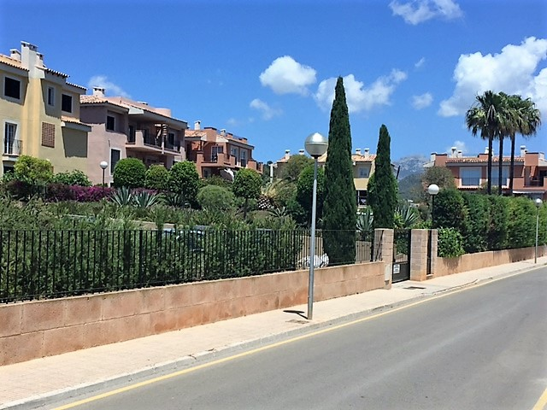
We are here!
- Use the zapper on your keyring to open the gate and park in no. 28, second slot from the right. Our flat is 1A, 1st floor on the left.
Happy hols!

